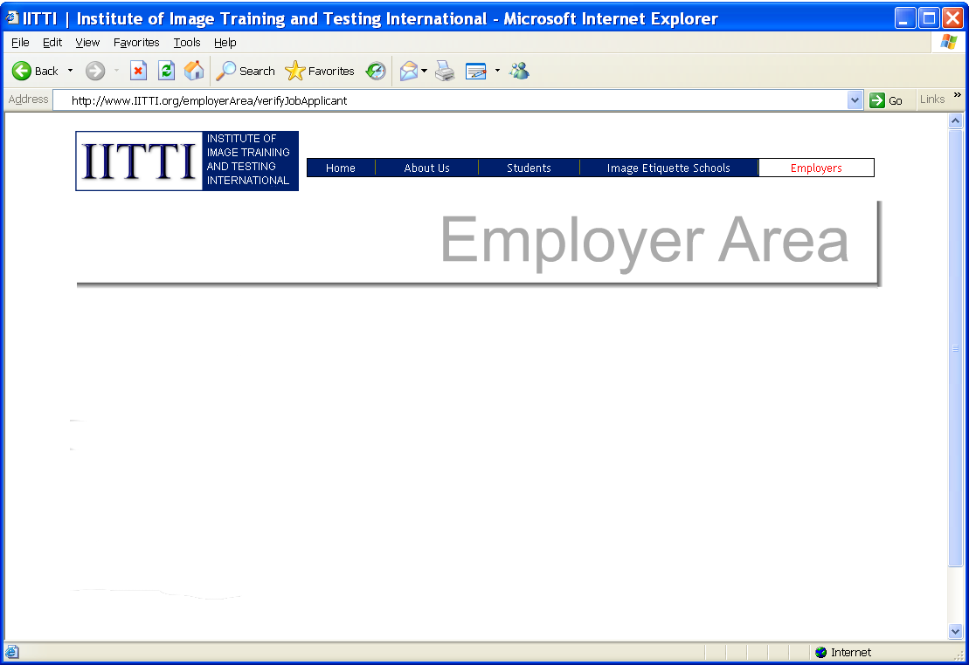



June 3, 2014
TM
_________________________________________________________________________________
Looking for a job?
Get an Edge with the IITTI Certificate
Résumé
Joyce Hilton
Corporate Basic
Companies can independently verify your
image credentials using the IITTI website
Want a good job? Promotion?
Understanding bosses' concern
Job market needs verification tool
Knowing your stuff is, of course, important. But it is not enough.

The secret to success lies in your ability to relate to others, and your image in terms of your appearance, behaviour and communication.
You need to understand that no boss wants an employee with an image that ruins the reputation of the company. No matter how well you can do the job, image makes or breaks your job opportunities.
Without exception, all Fortune 500 CEO's agree, the biggest challenge that they face is their ability to select and hire the best talents. The higher the position, the more it is not just about the ability of a candidate, but “people skills” such as etiquette, image, and ethics.
How can you show hiring companies that you have these soft skills?
According to surveys, human resources (HR) departments seek global standards for image and etiquette. And the IITTI certification offers just such a structure that job-seekers can follow, and HR's can easily verify once such training is completed.
With IITTI, you now have access to training and testing standards. Find out more about how you can attain the IITTI certification on global image and etiquette standards..
______________________________________________________________________________
IITTI
("ET")
helps job-seekers in verifying their etiquette training credentials to employers.
Web: www.IITTI.org
© 2011-2014 Institute of Image Training and Testing International
Name:
Certificate:
Contact your regional certified image consultant for details.
Just like you would write a TOEIC, TOEFL or IELTS test for your English skills, IITTI would be the equivalent test for your soft skills.
"How will I know she'll be the best bet for the job?"
Employer's thought:

